Home Learning Year 5
w/c 28/09/20

English  This week in English we are looking at writing a diary entry.  As our work is all focussed around ‘The Witches’  We are thinking back to when grandma lost her thumb and discussing different ways that this could have happened and why she was so secretive about it.  Our goal is to write a diary entry that includes all of the following things:  The date;  ‘Dear Diary’;  first person (I, myself, we, our);  past tense;  descriptive emotive language;  A clear description of the incident.  You don’t have to know the real reason why she lost her thumb. We are just going to have some fun writing ideas! You need to write all about the day that you lost your thumb. You are going to pretend that YOU are Grandma. Be as creative as you can! | Maths  This week in maths we will be practising calculating addition sums where there needs to be an exchange.  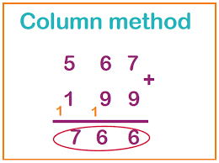  Please see the links for some helpful printouts to get you going! | Topic  This week in RE we are going to be looking at Sikhism and the way Sikhs practise their religion. There are lots of videos about this on BBC bite size. Could you write a booklets all about Sikhism?  For History we are going to be looking at the growth of Blackpool, from a fishing town to international tourism attraction.  Use the internet to see what detailed information about how Blackpool was affected by the tourism boom you can find online. You should add your opinion and explanation of your understanding alongside the facts collected, as you describe the changes. Could you create a powerpoint or online presentation?

